*March 28th, 2018*

**chapter 2 Basic concepts in minimization problems**

This chapter focus on the conditions that characterize the solution of mathematical minimization program and conditions under which the solution may be unique.

A general minimization program with constraints can be written (in standard form)as:



subject to 

The set of all possible values of that comply all constraints is known as the ***feasible region.*** This equations can be simplified by using vector notation. Let denote the array(vector) of decision variables, that is .The program above can be written as:



Subject to 

Note that all constraints are specified using a 'greater than or equal to' sign.

Equality of the type can be expressed as the pair of constraints and . The latter can be multiplied by -1 to conform to the standard form.

The solution of this program,is a feasible value of that minimizes ,that is

 for any feasible 

And 

Note that the number of may be 0,1,and more and correspond to the following three cases: no value of that satisfies all the constraints, the unique solution and many solution.

This book assumed that there is always **at least one value of **that satisfy all the constraints. This book deals only with programs that p**ossess a finite minimum** which occurs at a **finite value** of . In addition, this book deals only with the objective function and constraints **continuously differentiable.**

Three topics are each discussed separately: single-variable minimization programs, multivariable programs, and some special case of multivariable programs.

**2.1 Programs in one variable**

The discussion process of single-variable is shown as follows:

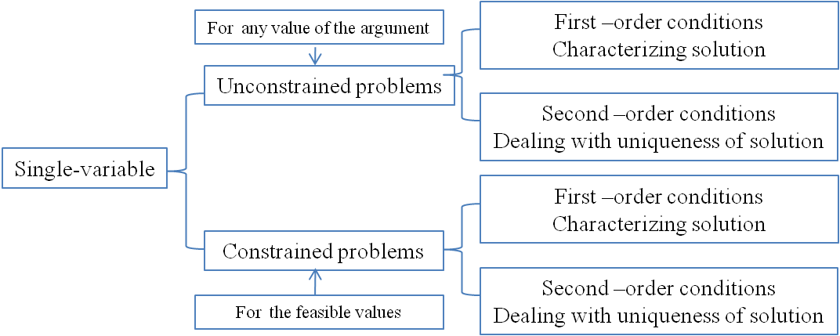

Figure 2.1.1 the discussion process of single-variable

**Unconstrained minimization problems**

***The first-order condition:*** the necessary condition for a differentiable function in one variable to have a minimum is that the derivative of evaluated at equals zero. That is

 [2.3]

However the first-order condition is not sufficient to ensure that is a minimum of . As demonstrated in figure 2.1.2, for four values of ,namely ,,,, all of which are ***stationary points*** of .

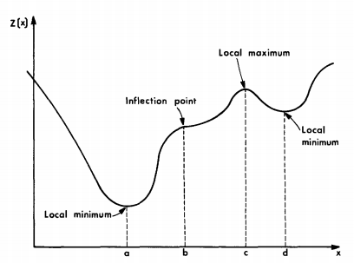

Figure 2.1.2 stationary points of 

To prove that a stationary point is a minimum, two characters must be demonstrated:（极小值的证明）

(1) it is a local minimum not a local maximum or an inflection point.(strictly, the first stage is to demonstrate a point is stationary point, and then to demonstrate the function is strictly convex in the vicinity of the stationary point)

(2)it is a global minimum.(that is ,this local minimum is lower than all the other local minimum).

***Ditonic unimodal*** is a function with a single local minimum. Of course, the single local minimum (stationary point)in ditonic function is a global minimum. A function is ditonic if it is strictly decreasing to the left of the minimum and strictly increasing to the right.(单峰函数的证明)

A sufficient condition for a stationary point to be local minimum is that the function is ***strictly convex***(heavy in the middle)in the vicinity of the stationary point.（驻点是局部极小值点的证明）

（凸函数的证明1）Formally，***strict*** (' less ' sign rather than ' less and equal to ' sign)convexity means that a line segment connecting any two points of the function lies above the function. Mathematically



Where . Which can be shown in figure 2.1.3. Note that this condition does not require that the function under consideration being differentiable.

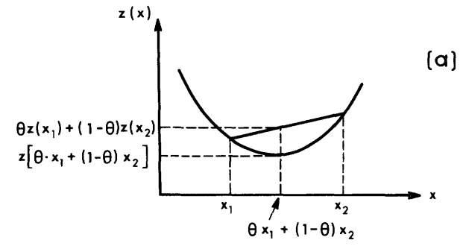

Figure 2.1.2 strictly convexity can be demonstrated by the first method.

（凸函数的证明2）Alternatively, strict convexity of differentiable function can be determined by testing whether the linear approximation to the function always underestimates the function. Thus is strictly convex at if and only if



Where, . This is demonstrated in figure 2.1.3.

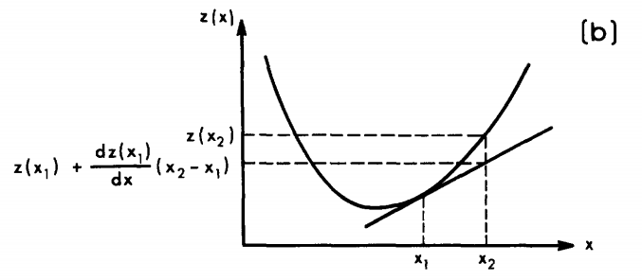

Figure 2.1.3 strictly convexity can be demonstrated by the second method

（凸函数的证明3）If a function is twice continuously differentiable in the vicinity of a stationary point, the strict convexity condition is equivalent to requiring that the second derivative of at be positive(the precondition is that the first differentiable must be zero). That is



(全局凸函数(单峰函数)的局部极小值是全局极小值)To demonstrate that a local minimum is unique, it is sufficient to show that is strictly convex of for all values of .

**Constrained minimization programs**

In constrained minimization it is possible to have a minimum where the first derivative does not vanish. For example, figure 2.1.4 showing the function defined over the feasible region. In the first case(2.1.4a), the minimum point is internal and the condition holds. However, in the second case(2.1.4b), the minimum point is on the boundary, at , .

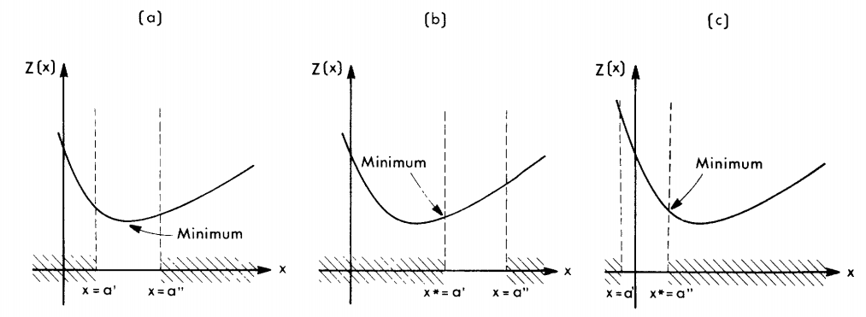

Figure 2.1.4 constrained minimum

When the minimum is on the boundary of the feasible region: if the constraint on which the solution lies (the binding constraint )is of the type,then the must be increasing (or more precisely nondecreasing )at (2.1.4b). On the other hand, the binding constraint is the type of , the must be decreasing (actually, nonincreasing) at (2.1.4c).

The problem depicted in figure2.1.4 can be written in a standard form, as follows:



Subject to 

The aforementioned observation means that the derivative of at and the derivative of binding constraint at this point will always have the same sign(or zero, never have opposite sign). This observation holds whenever a minimum occurs on the boundary of the feasible region as well as for an unconstraint solution. The condition of the same sign can be written as:

 for either or [2.6]

Where the is a nonnegative scalar, is the binding constraint.

At ,each constraint has two state, which are or .denote the constraint is binding and minimum point is on the boundary ;denote the constraint is not binding and the minimum point is inside the feasible region. Define nonnegative variable . If the jth constraint is not binding, let The development of first-order condition



holds for all the constraints.

Conditions 2.6 can be replaced by the condition



An unconstrained problem can be looked upon as a constrained problem with an internal minimum point, all , that is equivalent with eq.[2.3].

In summary, ***the first-order conditions for a constrained minimum are***

[2.7]

for 

（在‘的邻域内函数是凸的’前提下，函数在整个可行域内是凸的不能保证解释唯一的）The strict convexity of in the vicinity of would ensure that is a local minimum 。although the function is convex in the feasible region, but it can't guarantee the uniqueness of minimum. For example, in figure, the curve is strictly convex, but has two local minimum.

The Eqs.[2.7] is the necessary conditions for a minimum.(regardless of local or global).

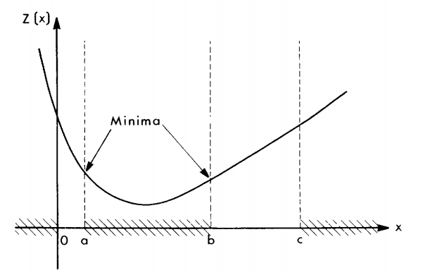

Figure 2.1.5 two local minimum for a strictly convex function bounded by a constrained set that is not convex.

Therefore, in addition to guarantee the strictly convexity of the objective function , uniqueness condition must be added, which is the feasible region must being convex. That is, any line segment connecting two points of that feasible region must lie entirely within the region. After the above two conditions is guaranteed, the local minimum at is global.( 邻域内函数严格凸性保证局部极小值，函数在整个可行域内凸的同时可行域也凸保证局部极小值是全局极小值，即解唯一)。

In conclusion, the sufficient conditions of unique minimum is the following three:  
(1)strict convexity in the vicinity of the minimum point(a local minimum is guaranteed).

(2)objective function is convex.

(3)feasible region is convex.(the local minimum is global)

**2.2 Multidimensional programs**

The multidimensional programs was written as:  
 

Subject to 

Where, ,.

The multivariable minimization programs deals separately with unconstrained and constrained problems, including a review of both first- and second-order conditions in each case. As in the preceding condition, the regularity conditions on and are assumed to hold, and a solution therefore always exists.

**Unconstrained minimization programs**

If the function to be minimized is unconstrained, ***the first-order condition for a minimum atis that the gradient of vanish at .***that is



Meaning that each component of the gradient(see Eq.[2.8]) has to be equal to zero. In other words,

 for 

The first-order condition is only a necessary condition for a minimum; that is, it establishes the fact that has a stationary point at ******.

The gradient of with respect to ,,is the vector of partial derivatives, that is

[2.8]

The subscript  in the gradient notation is usually omitted. At every point ,the gradient aims in the direction of steepest increase in .(梯度是使函数值增加最快的方向)

To show that a stationary point ******,is a local minimum, it is sufficient to demonstrate that is strictly convex in the vicinity of ******.（函数在******严格凸，说明******是函数的一个驻点）

(函数在全域严格凸或只在******处严格凸的前两个条件) If a line segment lies entirely above the function or it is underestimated by a linear approximately, the function is strictly convex.

The first strict convexity condition is （if the function is convex rather than strictly convex, the 'less than' sign is replaced by 'less than or equal to' sign）



Where, and are two different values of ,.

The second strict convexity condition is



(函数在全域严格凸或只在******处严格凸的第三个条件) The mathematical condition which ensures that is strictly convex is that Hessian , is positive definite.

The second derivatives of is known as the *Hessian,* denoted by .



Convexity associated with a positive-semidefinite(半正定) Hessian. A matrix is positive-semidefinite if and only if  for any nonzero vector .二次型正定的充要条件是，矩阵的左上角各阶主子式都大于零；负定的充要条件是的左上角各阶主子式都负正相间。

(有唯一一个局部极小点的条件) If a function is strictly convex everywhere, it has but one local minimum. Of course, this local minimum is the global minimum.

For concavity, the conditions of concavity is completely opposite to the convexity. Note that the sum of (strictly) convex functions is still a (strictly) convex function.

**Constrained minimization programs**

As in the single-variable case, the minimum of a constrained multidimensional program can occur on the boundary of the feasible region, where the first-order condition may not hold.

Consider the two-dimensional program depicted in fugure 2.2.1a. The problem is



Subject to 

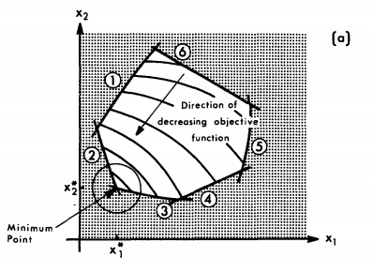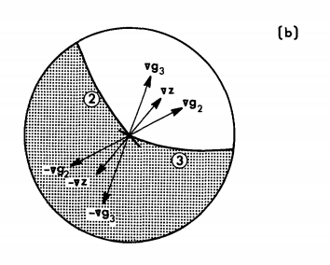

Figure 2.2.1 Kuhn-Tucker conditions:(a)contours of objective function and the feasible region;(b)the gradient of the objective function lies within the cone generated by the gradients of the binding constraints

As shown in 2.2.1b, the definition of the ***first-order conditions*** for constrained programs rests on the observation that the gradient of the objective function at the minimum point , ,must lie between the gradients of the binding constraints, and . This condition is a generalization of the "same sign" condition which was applicable in the single-variable case. That is, can be expressed as a linear combination(with nonnegative coefficients) of the gradients of the binding constraints. For the example in Figure 2.2.1, this condition is

.

Where and are nonnegative scalars associated with the second and third constraints, respectively. The same condition can be written in expanded notation as:  
  for 

***The generalization of the first-order condition to the constrained minimization programs in the multidimensional case.*** In a fashion analogous to the single-dimensional case, let be nonnegative if the th constraint is binding at , and let  for any nonbinding constraints. The first-order condition can now be written as follows:  
 for  [2.14a]

And ,,  [2.14b]

Conditions [2.14] are known as ***Kumn-Tucker conditions***. This are ***necessary conditions*** for a constrained minimum. The auxiliary variables are known as *dual variables* as well as *Lagrange multipliers(拉格朗日乘子)*. The condition ,, is known as the *complementary slackness condtion.* If none of the constraints is binding or the program is unconstrained, the first-order condition is simply .

Specially,  is a measure of the minimum value of  to the restriction imposed by the constraint. If the right-hand side of the constraint, ,is relaxed by some sall amount, , the minimum value of will decrease by .

*Attention,* there are some cases, which are seldom encountered in practice, in which the Kuhn-Tucker conditions do not hold at the minimum. Therefore a convex feasible region is defined.

The ***second-order condition*** for constrained multidimensional minimization programs to have a unique minimum include an additional requirement, that is, the constraint itself has to define a convex feasible region.

(有约束多变量极值问题有唯一极值点的三个条件)Hence, to ensure that is a global minimum, the following three conditions should be satisfied:(前两个条件都是二阶条件，最后一个是二阶条件的补充条件)  
(a)strict convexity of  at (如何保证)

(b)the convexity of  for all feasible .(如何保证)

(c)the convexity of the feasible region.

（a）的证明可以用在点处的海赛矩阵正定来证明

（b）的证明可以用在任意点的海赛矩阵正定来证明

Attention: it is sufficient to require only that a function be ditonic in order to ensure the uniqueness of a minimum.

总结：一阶导数可以证明是驻点，二阶导数可以证明函数在驻点处是凸的，以及函数在全域内是凸的。函数在驻点和全域内凸的证明方法是一样的，只不过一个自变量是，另一个自变量是全域内的任意。

This book deals exclusively with linear constraints and convex feasible region.（对于非线性规划来说，如果约束条件是线形的，那么目标函数一定是非线性的，也就是本书只讨论目标函数为非线性，约束条件为线形的非线性规划问题，其中，可行域是凸的）

**2.3 Some special programs**

This section deals with several cases of multidimensional constrained minimum programs that are of special interest in the study of equilibrium assignment, which are:

(a)programs with nonnegative constraints

(b)programs with equality constraints

(c)programs with both nonnegative and equality constraints

(d)linear programs.

Besides, an approach based on the concept of Lagrangians is introduced as an alternative of the first-order conditions of any minimization programs.

Now, review the first-order condition for constrained programs, which are posed with reference to the dual variables .

For the single-variable constrained programs, the first-order condition are as follows:  
[2.7]

for 

For the multivariable constrained programs, the first-order condition are as follows:  
 for  [2.14a]

And ,,  [2.14b]

**Nonnegativity constraints**

The first-order conditions for the case in which the feasible region includes all nonnegative values of can be posed without the reference to the dual variables .

In the one-dimensional case, the program "min subject to " can result in the two situations shown in figure 2.3.1.

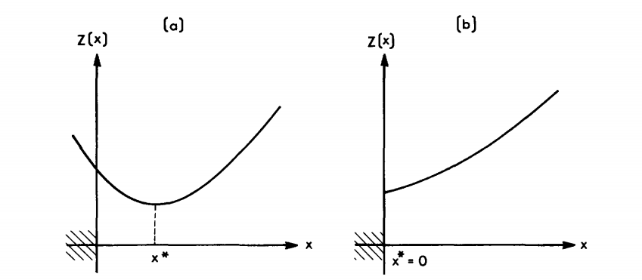

Figure 2.3.1 first-order conditions for a program with nonnegative constraints: (a)internal minimum with and ;(b) constrained minimum with ,and 

In the figure 2.3.1a, the solution is at a point where (and ). While in figure 2.3.1b, , since the nonnegative constraint is binding( and ).

The ***first-order condition*** for this problem(single-variable with nonnegative constraints) can be written in a form encompassing both these possible situations, as follows:  


The conditions above hold at the minimum point of (i.e., at )

Similarly, in the multidimensional case, the solution of the program



Sbuject 

can occur either for a positive [in which case ]or it can be on the boundary of the feasible region, where some .

Accordingly, the ***first-order conditions*** for this problem (multidimensional programs with nonnegative constraints)can be stated as:  


The above conditions hold at the minimum point of (i.e., at ).

**Linear equality constraints**

本节主要讲了拉格朗日在线形等式约束中的应用。其实质与库塔条件相同。

A convex function subject to a set of equality constraints, that is,

 [2.20a]

Subject  [2.20b]

Where is a constant.

***(the first-order condition 1)***The ***Kuhn-Tucker conditions*** for a stationary point of this program are as follows:  
[2.21a,2.21b]

At the solution point all the constraints are binding. The dual variables can have any sign.

***(the first-order condition 2)***These first-order conditions can also be derived by the method of ***Lagrange multipliers***. Specify an auxiliary function known as the ***Lagrangian ***



Where, are the original variables; are the dual variables, also known as ***Lagrange multipliers.***

The usefulness of this formulation is that the stationary point of the Lagrangian coincides with the minimum of the constrained optimization[2.20]. Since the Lagrangian is unconstrained, its stationary point can be found by solving the root of the gradient the Lagrangian . Note that the gradient is taken with respect to both types of variables, and . The gradient at the stationary point can be broken into two types of components,(驻点处一阶导数为0)

[2.23a]

[2.23b]

Condition [2.23a] means that

[2.24a]

Condition [2.23b] means that

[2.24b]

The conditions [2.24] are identical to the Kuhn-Tucker conditions [2.21], with the Lagrangian multipliers playing the same role with the dual variables in Eqs.[2.21].

Note that at any feasible point (of the original program)



Since the added term, ******,equals zero. In particular, note that the values of Lagrangian and the objective function are the same at the minimum point, .

(L的一阶导数为0求出的x能保证L取得最小值的前提是，L必须得是凸函数，这里应该已经隐含了这个意思)

**Nonnegative and linear equality constraints**

The general form of the problems with both linear equality constraints and nonnegative constraints is

 [2.25a]

Subject  [2.25b]

And  [2.25c]

Firstly, the Lagrangian with respect to the equality constraints should be formed as:

 [2.26a]

Then the stationary point of this Lagrangian has to be determined, subject to the constraint

[2.26b]

Consequently, the stationary point of program [2.26] has to be determined by the method used to define the first-order condition for nonnegative programs, shown in [2.19]. For program [2.26], these conditions are the following:  
 and [2.27a]

[2.27b]

 [2.27c]

The above conditions for nonnegative and equality constraints can be written explicitly as follows:  
[2.28a]

[2.28b]

[2.28c]

[2.28d]

The same conditions can be derived also by applying the Kuhn-Tucker conditions [2.14] directly.

**More about Lagrangians**

Lagrangians can be used to derive the first-order conditions for general mathematical programs such as



Subject to 

This program can include any type of constraints.

The Lagarangians for this program is given by



The dual variables in this formulation are restricted to be nonnegative, due to the "greater than or equal to" type of constraints. (in equality constraints, the dual variables are unrestricted in sign)

As it turns out, the stationary point of the Lagrangian of a convex function is not at a minimum or at a maximum of ******but rather at a ***saddle point*** of the Lagrangian, as shown in figure 2.3,2. In fact, ******minimizes ******with respect to  and maximizes it with respect to ******.(因为拉格朗日的前半部分是关于x的凸函数，后半部分是关于u的凹函数) this condition can be stated as



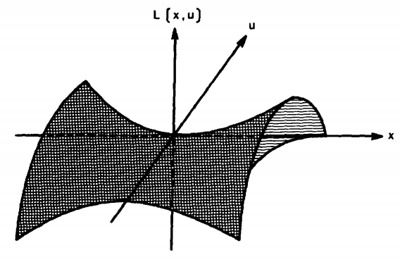

Figure 2.3.2 Saddle point of a two-argument function. The point (0,0) maximizes ******with respect to u and minimizes ******with respect to x

Note that its minimization is unconstrained with respect to x. The maximization with respect to u, is subject to the nonnegative constraints. The saddle point of ******satisfies the following set of first-order conditions:

 [2.32a]

[2.32b]

[2.32c]

Condition [2.32a] states simply that the gradient vanishes at the stationary point.

Cinditions [2.32b] parallel condition [2.19] but for a maximum of a function(see also Eq.[2.27a]) . Since  has to be maximized with respect to ******.The maximum of  with respect to  can occur either at a point where or at a point where . In the latter case, it must be true that . This observation gives rise to conditions [2.32b].

Conditions [2.32] can be written explicitly as (these conditions are identical to Kuhn-Tucker conditions [2.14])



Note that the functional form of the Lagrangian demonstrates why the dual variables can be interpreted as a measure of the sensitivity of the optimal solution to a constraint relaxation, as argued in Section 2.2 At the solution point,

******[2.34]

At this point. If the th constrained is relaxed by a small amount, ,and in [2.34] is replaced by , the new minimum value of will approximately equal the old value minus . Thus a relaxation of the th constraint by improves the optimal value of the objective function by, approximately, .

**Linear Programs**

In a linear minimization program, both the objective function and the constraints are linear functions of x, which can be written as



Subject to 

Where  and  are constants and the summations go from to .

The ease of solving linear programs results from the fact that their solutions never lie at an internal point but always at the boundary of the feasible region. Furthermore, if a solution exists, it will always be at a " corner " of the feasible region. Thus, only the corner points of this region have to be checked. This property is intuitively apparent in figure 2.3.3.

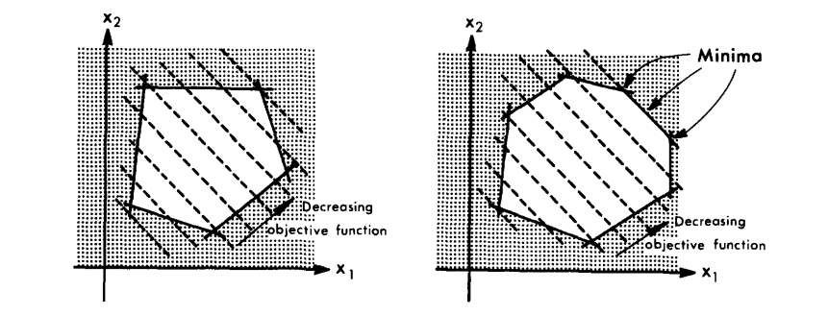

Figure 2.3.3 linear programs in two variables: (a) the solution is at a corner of the feasible region ;(b)multiple minima.

In some cases, multiple minima [all with the same value of ] may exist(since the "strict convexity " condition does not apply to linear programs), as illustrated in Figure 2.3.3b. Some of these minima, however, will always be at the intersection of several constaints.